-- EXERCISE 5

-- 1. List all employees who hold the titles of “Senior Programmer” and “Multimedia Programmer”.
SELECT F_NAME, L_NAME, TITLE
FROM EMPLOYEE_DATA
WHERE TITLE IN ('Senior Programmer', 'Multimedia Programmer');
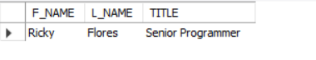

-- 2. List all employee names with salaries for employees who draw between ₱70,000 and ₱90,000.
SELECT F_NAME, L_NAME, SALARY
FROM EMPLOYEE_DATA
WHERE SALARY BETWEEN 70000 AND 90000;
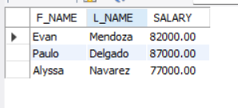

-- 3. What will the following statement display?
SELECT F_NAME, L_NAME, TITLE
FROM EMPLOYEE_DATA
WHERE TITLE NOT IN ('Programmer', 'Senior Programmer', 'Multimedia Programmer');
-- IT WILL DISPLAY ALL EMPLOYEES WHOSE TITLES ARE NOT RELATED TO PROGRAMMING.
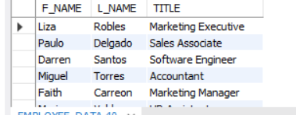

-- 4. Here is a more complex statement that combines both BETWEEN and IN.What will it display?
SELECT F_NAME, L_NAME, TITLE, AGE
FROM EMPLOYEE_DATA
WHERE TITLE NOT IN ('Programmer', 'Senior Programmer', 'Multimedia Programmer')
AND age NOT BETWEEN 28 AND 32;
-- THIS DISPLAYS EMPLOYEES WHO ARENOT PROGRAMMERS OF ANY TYPE, AND NOT BETWEEN 28 AND 32 YEARS OLD, IT WILL BE UNDER 28 OR OVER 32.

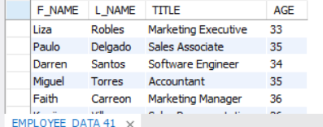

CREATE DATABASE EXERCISE5_DB;
USE EXERCISE5_DB;
CREATE TABLE EMPLOYEE_DATA (
EMP_ID INT AUTO_INCREMENT PRIMARY KEY,
F_NAME VARCHAR(50),
L_NAME VARCHAR(50),
AGE INT,
SALARY DECIMAL(10,2),
TITLE VARCHAR(100)
);
INSERT INTO EMPLOYEE_DATA (F_NAME, L_NAME, AGE, SALARY, TITLE) VALUES
INSERT INTO EMPLOYEE_DATA (F_NAME, L_NAME, AGE, SALARY, YOS, DIVISION, TITLE) VALUES
('Evan', 'Mendoza', 34, 82000, 4, 'IT', 'Programmer'),
('Liza', 'Robles', 33, 94000, 3, 'Marketing', 'Marketing Executive'),
('Paulo', 'Delgado', 35, 87000, 2, 'Sales', 'Sales Associate'),
('Ricky', 'Flores', 45, 105000, 5, 'IT', 'Senior Programmer'),
('Darren', 'Santos', 34, 92000, 6, 'IT', 'Software Engineer'),
('Miguel', 'Torres', 35, 125000, 7, 'Finance', 'Accountant'),
('Faith', 'Carreon', 36, 122000, 8, 'Marketing', 'Marketing Manager'),
('Marina', 'Valdez', 28, 62000, 2, 'HR', 'HR Assistant'),
('Gwen', 'Perez', 30, 67000, 1, 'Marketing', 'Marketing Staff'),
('Marco', 'Padernal', 27, 60000, 2, 'IT', 'Programmer'),
('Kenji', 'Villanos', 26, 57000, 2, 'Sales', 'Sales Representative'),
('Manuel', 'Santos', 40, 98000, 9, 'Marketing', 'Marketing Head'),
('Alyssa', 'Navarez', 31, 77000, 4, 'IT', 'Junior Programmer');

